Quattro™
Outdoor Advertising Management System

Inventory Control Module - Version 4.7.0.63



Contents
Inventory Control System 2
Introduction. 2
Main Toolbar 2
Manage Bins 3
Add New Bin 3
Edit Bin Name 3
Delete Bin 3
Manage Inventory 3
Find Copy 4
Pull Copy 4
Transfer Copy 5
Receive From Transfer 6
Discard Copy 6
Manage Inventory -Receive Copy 8
Correcting Copy 9
Received 9
Received Inventory Log 9
Location of Copy 12
Match Copy 12
Clear Matched Design 14
Receiving Notes 14
Summary 14
Inventory Maintenance 15
Set Discard Date 17
Set Manual Discard Date 17

Inventory Control System

Introduction.
The inventory control module is designed to track the following:
- incoming copy
- where it’s being stored
- how many have been used for posting
- how many are left over
- when the copies are to be discarded

Main Toolbar
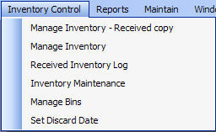

Manage Inventory – Received Copy | All received copy is recorded here. Copy is received to bins and notes can be attached about the receipt.
Manage Inventory | Finding, Pulling, transferring, receiving from transfer (from one plant to another) and discarding copy is done here.
Received Inventory Log | Provides a log of all received copy, a summary of designs in stock (When matched with received copy) and the ability to filter the information by design, advertiser, product category, sales executive and received date.
Inventory Maintenance | Transfer copy inventory from one bin to another to reflect changes in copy location. Also the ability to enter design quantities that exist in bins
Manage Bins. | Define the names of all bins where copy will be stored.
Set Discard Dates. | Define discard dates for copy.

Manage Bins

The first step to managing the copy inventory is to enter the bin names where copy is stored. Click the Menu Option Inventory Control, then Manage Bins.
To add a new Bin, double click within the grid.

Add New Bin
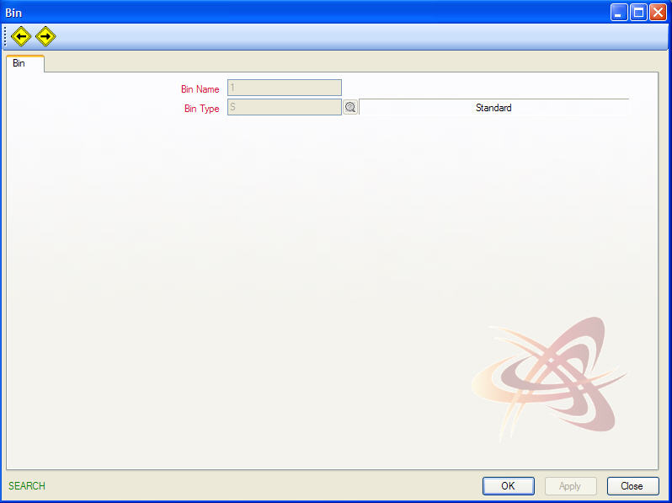
Enter a Bin name and from the browse window select a Bin Type. Click Apply to save.

To edit a bin name, use CTRL – E to enter edit mode. Make the change to the Bin Name field and click Apply to save. Use CTRL – F to search for the bin you want to edit. Double click the bin to bring the Bin window up.

Edit Bin Name

Delete Bin
To delete a bin, use CTRL – F to find the bin you want to delete. Double Click on the Bin to be deleted and use CTRL - D.
Note: once a bin has been used to log inventory, it cannot be deleted from Quattro. To make adjustments, edit the bin name.
Once the bin names are entered, there is no need to go back into this screen unless bins need to be created, edited or deleted.

Manage Inventory

Once the bins have been created in Quattro, you can begin to manage the inventory. From the main select Manage Inventory

There are five tabs on this window: Find Copy, Pull Copy, Transfer Copy, Receive From Transfer and Discard Copy. The window defaults to the Find Copy tab. This is where the information about copy that has been received is entered.

Find Copy allows you to search for copy location using a design or advertiser code.

Find Copy

Design Code | Enter / browse to find the design code and determine the location of the copy for any given design.
Advertiser Code | Enter / browse to find the advertiser code to see the location of copy for any given advertiser.
Snipe Search Code | If known, enter the snipe code.
Include Snipes for Design | Click to turn the check box ‘on’ if looking for a snipe.
Grid | Summarizes information pertaining to location and quantity of specified copy. It displays the Bin names that the design can be found in, the quantity available in each bin, the design code, name of the design, and the advertiser name.
To view the designs that match the information you entered, press tab on your keyboard or click refresh and the design, along with additional information will be displayed in the grid.
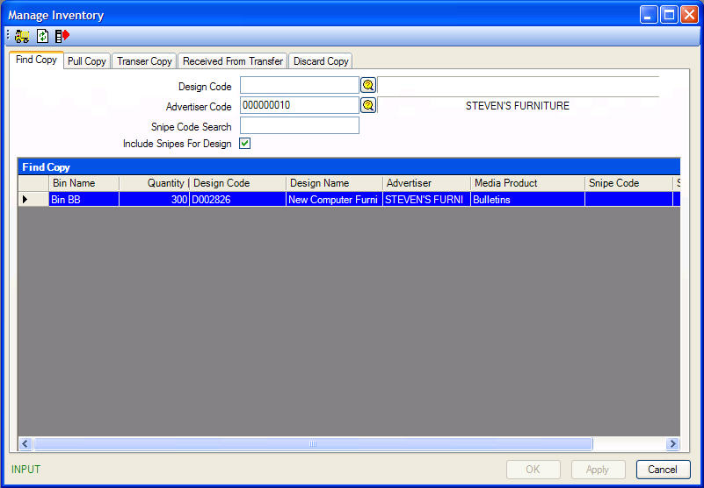
The Pull Copy allows you to remove or pull copy from inventory, whenever copy is used. This helps to keep accurate quantities of copy and control where the copy is located.

Pull Copy
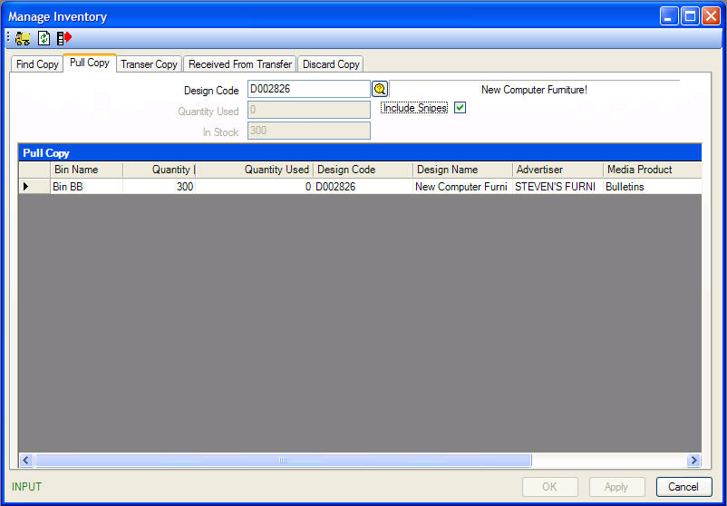
Design Code | Enter (or browse for) the design code for the copy being pulled. Refresh the screen to see the relevant information for that copy.
Include Snipes | Click this check box ‘on’ if you wish to see snipes.
Grid – Quantity Used | In the Quantity Used column, enter the number of copies being pulled from the appropriate bin for posting.

Once you have entered the quantity used from the correct bin, click on the APPLY button and the screen will update the Quantity remaining in each bin.

To transfer copy to another plant, use the transfer copy feature.

Transfer Copy
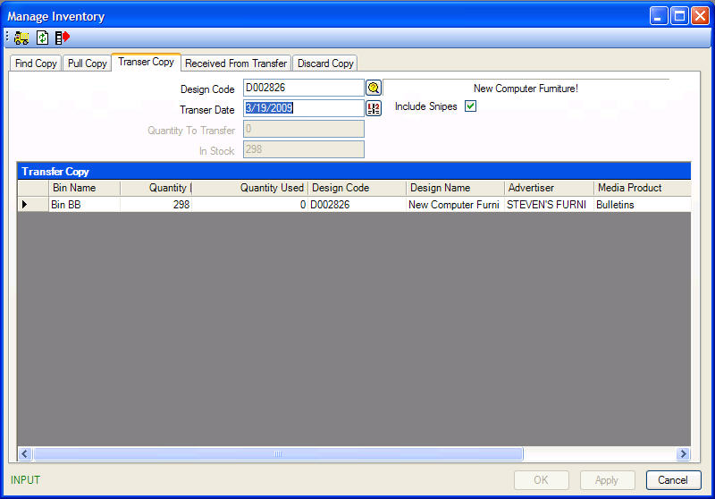

Design Code | Enter (or browse for) the design code of the copy to be transferred.
Transfer Date | The date you want the transfer to take place
Quantity to Transfer | This field will update when the Quantity to be transferred is entered in the Quantity Used field in the lower grid.
Include Snipes | Click this check box ‘on’ if you wish to see snipes.
In Stock | This shows the number of copies of the design that are currently in stock.
Grid – Quantity Used | Enter the number of copies that you are transferring to another plant.
Once, you have entered the Design code and Transfer date, press tab on your keyboard or click on the Refresh button, to display and designs that match the information you entered.
Click APPLY to transfer the copy amount you entered in the Quantity used field. The Quantity field will update.

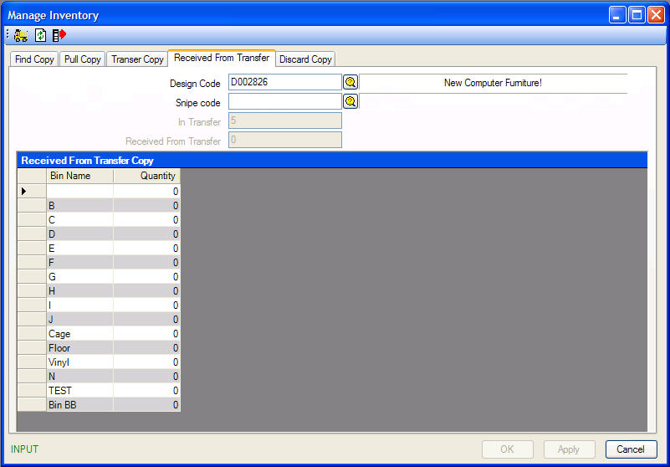

Receive From Transfer
When copy is received from another plant, its receipt needs to be recorded.
Design Code | Enter (or browse for) the design code for the copy coming from another plant.
Snipe Code | Enter (or browse for) the snipe code for the snipe coming from another plant.
In Transfer | This field shows how many copies are in transfer from the other plant.
Received From Transfer | This field will update when the Quantity received is entered in the Quantity field in the lower grid.
Grid – Quantity | In the Quantity field enter the number of copies received beside the appropriate bin.
Once, you have entered the Design code and Transfer date, use the bin list, and enter the quantity received from transfer in the Quantity column next to the corresponding bin and click APPLY to update the Received From Transfer box.

Copy is automatically given a discard date equal to 90 days (this setting can be changed) from the last “active” contract date the copy is used in. This discard date is a guideline which allows discard reporting for old copy. If copy is tagged to be discarded, use this tab to pull out of inventory when it is physically discarded from the plant.

Discard Copy
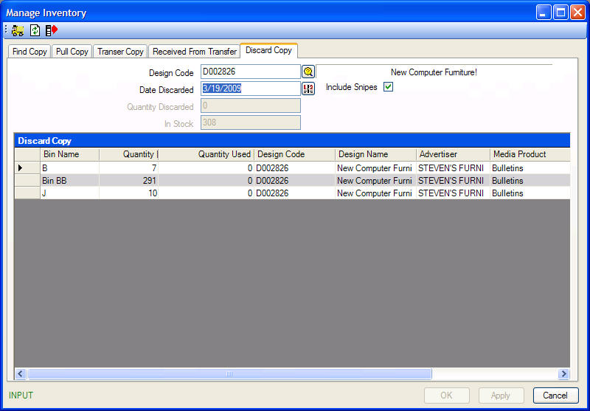

Design Code | Enter (or browse for) the design code for the copy to be discarded.
Date Discarded | Enter the discard date (default = current date).
Include Snipes | Click this check box ‘on’ if you wish to see snipes.
Quantity Discarded | This field will update when the Quantity Used is entered in the Quantity Used field in the lower grid.
In Stock | This shows the number of copies of the design that are currently in stock.
Grid – Quantity Used | In the Quantity Used field enter the number of copies to be removed from the bin and discarded.
Once you enter the Design code and date that the design is discarded, press tab on your keyboard or click the Refresh button. The bottom grid will update with the number of bins that the current design is located in. You can enter the amount of copy being discarded in the Quantity used column and click APPLY to update the total quantity discarded.

Manage Inventory -Receive Copy

Copy received into the plant is entered here. Click on menu option Inventory Control, then Manage Inventory – Receive Copy.
Also, this can be accessed from the Manage Inventory screen by clicking on button.
To access the Manage Inventory screen, click on button from here.
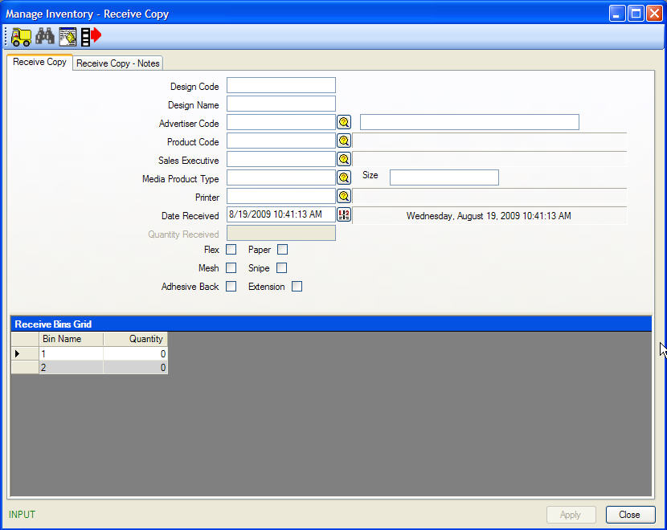

When copy is received, enter as much information as is known about the copy. A design name, received date and Bin quantity is required in order to save the copy, but it is recommended to enter as much information as possible to aid in matching the copy to a charting design in the system.
Design Code | This code will be entered in Design Maintenance in the Charting Module. The design code will be picked up in the Copy Inventory module when the copy is matched with the design.<Optional>
Design Name | Enter the design name or a description of the copy. (Mandatory)
Advertiser Code | If you know the Advertiser Code, enter it here. Otherwise, use the browse button to view a list of advertiser codes.<Optional>
Product Code | If you know the product code, enter it here. Otherwise, use the Browse button to view a list of Product codes. <Optional>
Sales Executive | If you know the Sales Executive, enter it here. Otherwise, use the Browse button <optional>
Media Product Type | If you know the Media Product type, enter is here. Otherwise, use the Browse button to view a list of Media Product Types. <optional>
Size | If known, enter the size of the copy.<optional>
Adhesive Back/Snipe/Extension | Use the check boxes to indicate the appropriate characteristics.<optional>
Printer | Enter the name of the printing company responsible for producing the copy.<optional>
Date Received | Enter the date the copy was received. (Mandatory)
Receive Bins - Grid | Left-click in the Quantity cell beside the appropriate bin and enter the number of copies that have been received. Press Tab on your keyboard to update the Quantity Received box above. (Mandatory)
Receive Copy - Notes Tab | Use this tab to enter any relevant notes about the received copy. These notes will display on the Inventory – Received Copy report.
Once you have entered the necessary details about copy received, click APPLY to save the entry.

If you need to correct information on copy received, click the Binoculars from the Manage Inventory – Receive Copy window to open a list of copy received.

Correcting Copy

Received
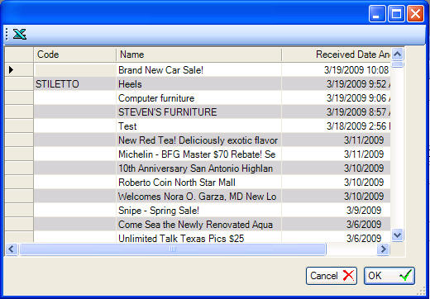
Highlight the entry that needs to be corrected and click OK to open its Received details for adjustment.
After making the necessary corrections, click APPLY to save.

Received Inventory Log

Copy inventory received and logged into Manage Inventory will appear in the Received Inventory Log with the details entered upon receipt and details provided by Charting. As the list of copy received may grow quite rapidly, use the Filter & Refresh tab to set a filter for the inventory displayed.
Filter & Refresh

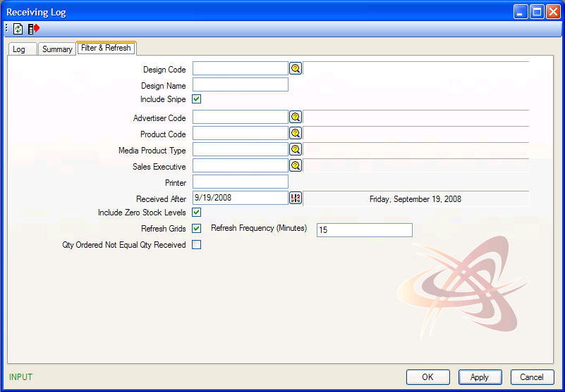

Design Code | This code will be entered in Design Maintenance in the Charting Module. The design code will be picked up in the Copy Inventory module when the copy is matched with the design. If you do not know the design code, click the Browse button to conduct a search.
Design Name | Enter the design name to search for designs received with the same name.  Note: This filter will display results with an exact match. Be careful of spelling and use of grammatical characters.
Include Snipe | To exclude Snipes in the list of copy received, check “off” this box.
Advertiser Code | If you know the Advertiser Code, enter it here. Otherwise, use the browse button to view a list of advertiser codes.
Product Code | If you know the product code, enter it here. Otherwise, use the Browse button to view a list of Product codes.
Media Product Type | If you know the Media Product type, enter is here. Otherwise, use the Browse button to view a list of Media Product Types.
Sales Executive | If you know the Sales Executive, enter it here. Otherwise, use the Browse button
Printer | Enter the name of the printing company responsible for producing the copy.  Note: This filter will display results with an exact match. Be careful of spelling and use of grammatical characters.
Received After | Will display all copy received after the date entered.
Include Zero Stock Levels | By default, the log will exclude inventory received that has been used and discarded. To include inventory with zero stock, check this box “on”.
Refresh Grids | Since copy inventory may be being logged while you are using the Receiving Log, scheduling the log to refresh automatically every 15 minutes will ensure you have an accurate log. To refresh the list more (or less) frequently, adjust the number of minutes.
Refresh Frequency (Minutes) | Enter the number of minutes for the grid to refresh.
Qty Ordered Not Equal Qty Received | Filter for receipts quantities that do not match what was ordered.

After setting your filter, click the Refresh to conduct a search. Click on the Log tab to view the results. We will use the copy World’s Largest Indoor Flea Market as our example.
Log
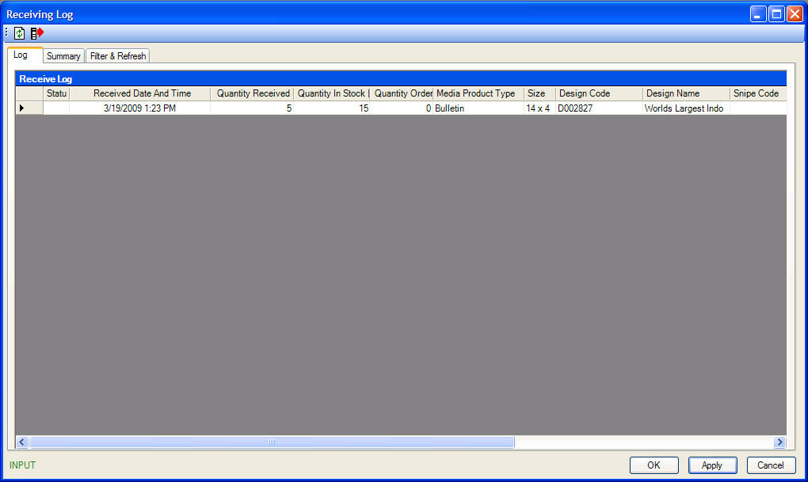

Status | Status of association between copy received by operations and charting design information (blank = matched, M=Matching required, S=A system match is available, formal matching still required).
Received Date | Date copy was received. Entered in Manage Inventory upon receipt of inventory.
Quantity Received | Quantity of copy inventory received. Entered in Manage Inventory upon receipt of inventory.
Quantity In Stock | Current quantity of copy in stock. Once copy has been “matched” it is assigned a design code which then can be used to update quantity in stock using Manage Inventory or Inventory Maintenance.
Quantity Ordered | Quantity of design ordered (from charting).
Media Product Type | Media Product Type associated to the copy received.
Size | Measurements of the copy received. Entered in Manage Inventory upon receipt of inventory.
Design Code | A code assigned by charting. Typically an automatic incrementing number.
Design Name | The charting design name/description.
Snipe Code | A code assigned by charting. Typically an automatic incrementing number.
Snipe Name | The charting snipe name/description.
Extension | Yes or No. Entered in Manage Inventory upon receipt of inventory.
Advertiser | The advertiser associated to the design copy was matched to.
Account Manager | The sales executive associated to the campaign in which the design is scheduled on.
Printer | Name of company responsible for producing the copy. Entered in Manage Inventory upon receipt of inventory.

Location of Copy
To view the location (bin) where copy is received, highlight the copy in question, right-click and select Location of Copy from the menu.

All copy inventory received needs to be associated to an advertiser’s creative in charting. Quattro does not automatically match copy to valid designs in the Charting module.

Match Copy

In the Receiving Log, the Status column states whether a design has been “matched” to an advertiser.

M | The copy has not bee matched to an advertiser.
S | Quattro has found a similar design that it believes it should be matched to, but requires user confirmation.
Empty Cell | Copy has been matched to a charting design.

To match copy received with design information entered in Charting, Right-click on the design and selects Match Copy to Design or double click on the copy from the receiving log tab’s grid. Use filter & refresh to filter for copy you want to match (I.E, for specific media product). Note the filter & refresh tab looks at designs in charting. If copy is not yet matched, it cannot be filtered by Design code, Advertiser Code, Product Code as these flow over from charting.
For unmatched copy filter for media product or design name.

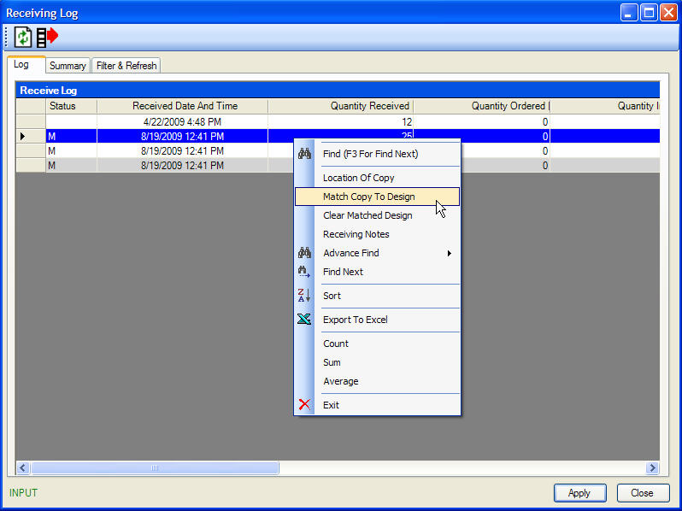

The Match Design window will appear displaying the Receiving Detail entered by Operations on the left-side of the window, the search options on the right-side of the window and the potential designs that match the copy received in the grid below.

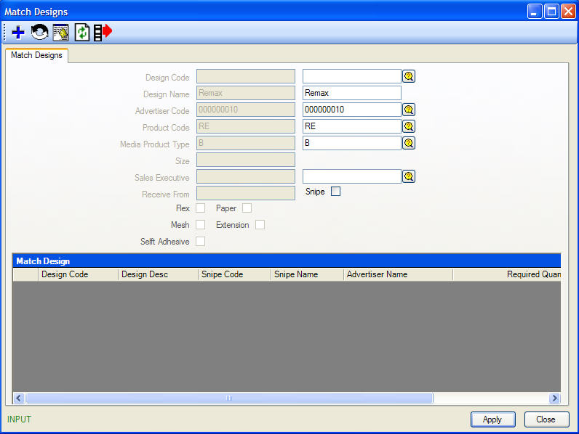
Using the copy name specified in the Receiving Detail, Quattro will search for designs with a similar design name in the Charting module. If the system finds any with the same name, it will display them in the lower grid.
If no match is found, you can modify any of the fields in the Search for Design box, and click refresh button to update the lower grid with any matches.
In the example above, the design name Steven’s Furniture was not found in Charting, however the Advertiser Code 00000010 was and had a Design with the description of Stevens furniture event.
Once you have found the correct design, highlight it in the lower grid and click OK to “match” the two entries.

Note: If no match can be found and you are responsible for adding charting design information, click the Add button in the Match Copy window to open Design Maintenance and add the new design.
Once the match has been made and the screen is refreshed, the ‘M’ in the status field will disappear and additional details from charting populate the Receiving Log.

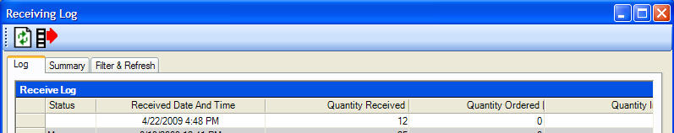
If copy was accidentally matched to the wrong design, the receiving details can be easily retrieved by clearing the matched design.

Clear Matched Design
Highlight the copy incorrectly matched, right-click and select Clear Matched Design. The copy will automatically update with the original information.

To view notes that may have been entered when copy was initially received and logged into Quattro, highlight the row of copy details, right-click and select Receiving Notes from the menu.

Receiving Notes

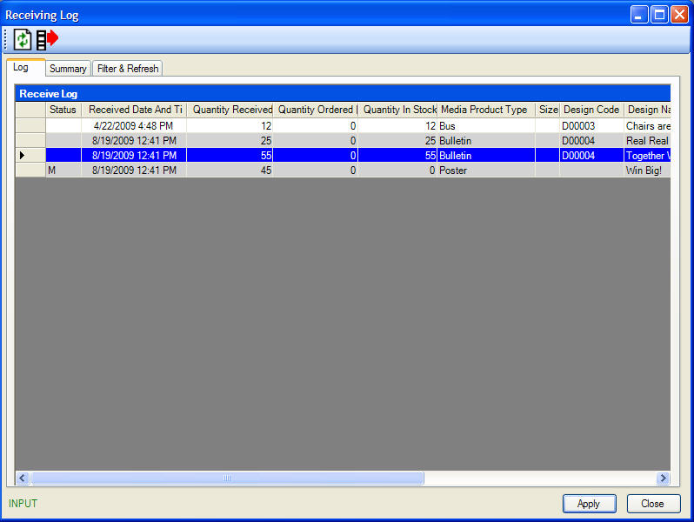

Summary
The Summary tab provides a list of all copy and designs that have been matched. Aside from Quantity in Stock, it also includes Quantity in Transfer and Quantity Reserved. The Quantity Reserved updates based on the number of locations the design is scheduled to post on.

Inventory Maintenance
Inventory Maintenance is where the movement of copy in and out of bins is recorded. The window displays all matched copy which is in stock.
The list of copy may be quite extensive so we suggest beginning this process by setting a filter.

Filter
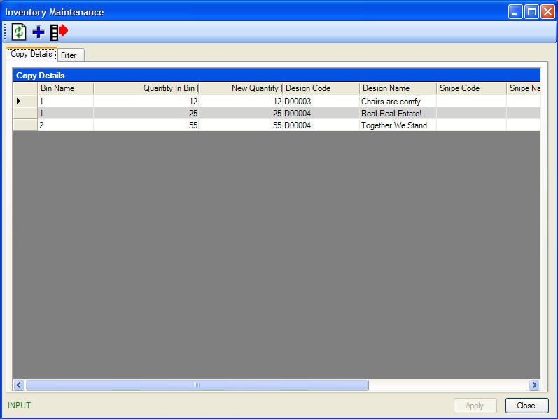
Design Code | Date copy was received. Entered in Manage Inventory upon receipt of inventory.
Include Snipes | Quantity of copy inventory received. Entered in Manage Inventory upon receipt of inventory.
Advertiser Code | Current quantity of copy in stock. Once copy has been “matched” it is assigned a design code which then can be used to update quantity in stock using Manage Inventory or Inventory Maintenance.
Bin Number | Media Product Type associated to the copy received.
Sales Executive | Measurements of the copy received. Entered in Manage Inventory upon receipt of inventory.
Media Product Type | A code assigned by charting. Typically an automatic incrementing number.
Include Zero Stock Levels | The charting design name/description.

After setting your filter, click the Refresh button to view results of your search.
To move copy from one bin to another, click in the New Quantity cell and enter the remaining amount in the original bin. Press tab on your keyboard and click OK to save.
You can add a design to your copy inventory by clicking . Search for the design and Bin name. Enter the quantity in the Bin and click OK to save the design and the quantity you added to the Bin.

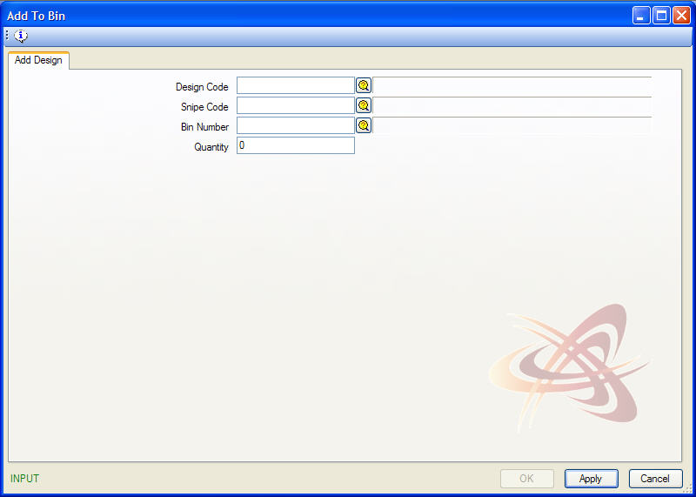

Set Discard Date

Quattro assigns a discard date to all copy. This date is 90 days past the last posting date of the copy. The Inventory – Copy Due for Discard report provides a list of all copy due to be discarded. This list can be reviewed to determine if there is any copy that should or should not be discarded. If there is copy not to be discarded, a manual discard date can be applied.

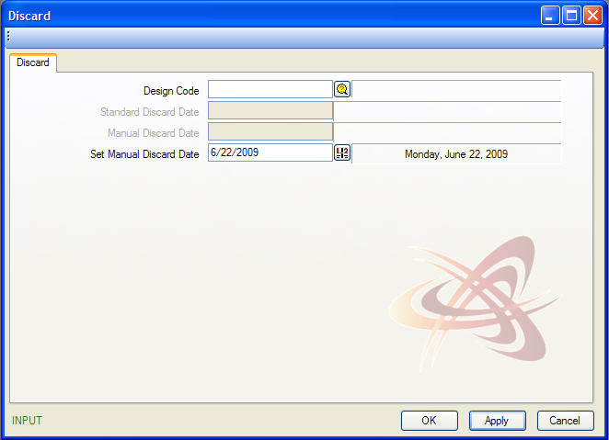

Set Manual Discard Date

Click the Set Discard Date button from the main toolbar.

Enter the design code or conduct a search using the browse button.

Press the tab button on your keyboard to view the Standard Discard Date.

Use the calendar button or manually type a Manual Discard Date and click OK to save.

Note: Quattro will not automatically discard quantity in stock when the discard date has passed. Use the Discard function in Manage Inventory to discard copy used.

